PROJECT REPORT

**DIGITAL MARKETING - NAAN MUDHALVAN**

**CREATING AN GOOGLE ADVERTISEMENT**

*SUBMITTED BY*

Team ID:

10EA79BA4AE54CFB5BE481B49078887

Team Leader:

SHENOY HAYDEN (2020504582)

Team members:

RISHI VHARSUN J (2020504569)

JEEVANANTHAM (2020504535)

SAM PREETHAN (2020504575)

in partial fulfilment for the award of the degree of

BACHELOR OF ENGINEERING

IN

ELECTRONICS AND COMMUNICATION ENGINEERING

DEPARTMENT OF ELECTRONICS ENGINEERING

MADRAS INSTITUTE OF TECHNOLOGY

ANNA UNIVERSITY: CHENNAI 600 044

**TABLE OF CONTENTS**

1. INTRODUCTION
   1. OVERVIEW
   2. PURPOSE
2. PROBLEM DEFINITION AND DESIGN THINKING
   1. EMPATHY MAP
   2. IDEATION AND BRAINSTORMING MAP
3. RESULT
4. ADVANTAGES AND DISADVANTAGES
5. APPLICATIONS
6. CONCLUSION

**INTRODUCTION**

**OVERVIEW:**

Google Ads is an online advertising platform developed by Google that allows businesses and advertisers to create and manage online ads to reach a wide audience. It's one of the most popular and effective methods for businesses to promote their products or services on the internet. Google Ads offers a variety of ad formats, including text ads, display ads, video ads, and app ads. These ads can

appear on Google's search results pages, websites in the Google Display Network, YouTube, and within mobile apps.

**PURPOSE:**

Google Ads serves as a versatile and powerful tool for businesses and advertisers to reach their target audience, generate leads, increase sales, and achieve various marketing goals while providing the flexibility to adapt and optimize their campaigns. Some of it are

* Advertising
* Online Visibility
* Targeted Marketing
* Brand Awareness
* Ad Testing and Optimization

**PROBLEM DEFINITION AND DESIGN THINKING**

Creating Google Ads involves several steps. Here's a brief overview:

Set Up a Google Ads Account - Choose Campaign Goals - Campaign Type - Target Audience - Set a Budget - Create Ad Groups - Choose Ad Extensions and it goes on with few more of steps . Finally the google will review our ads and the process will end . Depending on our results, we can scale up successful campaigns or refine those that underperform.

Creating and managing Google Ads campaigns can be an ongoing process, involving constant optimization and adjustments to improve their effectiveness and achieve your advertising objectives.

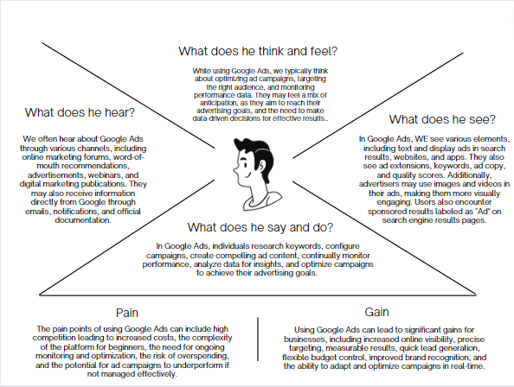**EMPATHY MAP:**

**IDEATION AND BRAINSTROM MAP:**

**Step-1: Team Gathering, Collaboration and Select the Problem Statement**

**Step-2: Brainstorm, Idea Listing and Grouping**

**Step-2: Grouping**

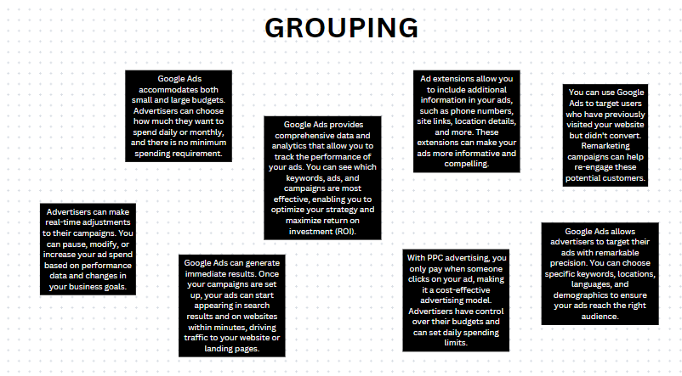

**Step-3: Idea Prioritization**

**RESULT**

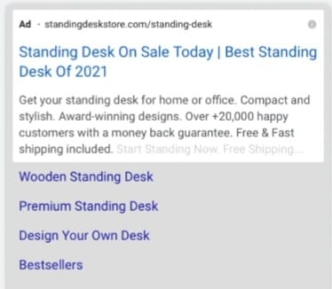

**ADVANTAGES AND DISADVANTAGES**

**ADVANTAGES OF GOOGLE ADS**

**Highly Targeted Advertising:** Google Ads allows you to reach a specific audience with precision, ensuring your ads are seen by users interested in your products or services.

**Cost-Effective:** With a pay-per-click (PPC) model, you only pay when someone clicks on your ad, making it a budget-friendly advertising option.

**Instant Visibility:** Google Ads can quickly put your business at the top of search results, providing immediate online exposure to potential customers.

**Detailed Performance Tracking:** You can monitor ad performance in real-time, enabling data-driven decision-making and optimization of your campaigns.

**Flexible Budgeting:** Google Ads accommodates a wide range of budgets, allowing businesses of all sizes to participate in online advertising and adjust spending as needed.

**DISADVANTAGES OF EMAIL CAMPAIGN**

**Costly Competition:** The competitiveness of Google Ads can drive up bid prices, making it expensive for some businesses, especially in highly competitive industries.

**Ad Click Fraud:** Click fraud, where competitors or malicious users click on your ads to deplete your budget without genuine interest, can be a concern.

**Complexity:** The platform can be complex and overwhelming for beginners, requiring a learning curve to effectively manage campaigns.

**Ad Blocking:** Many users employ ad blockers, reducing the reach of Google Ads and potentially impacting the return on investment.

**Ad Blindness:** Some users have developed "ad blindness" and tend to ignore or skip over ads, reducing their overall effectiveness in certain contexts.

**APPLICATIONS**

Google Ads has a wide range of applications for businesses and advertisers. It can be used to increase website traffic, generate leads, boost sales, and raise brand awareness. Advertisers can target specific demographics, locations, and interests, ensuring their messages reach a relevant audience. It's also valuable for promoting mobile apps and driving app downloads. Google Ads is particularly effective for e-commerce, as it allows product listings and shopping campaigns. Additionally, it's a powerful tool for local businesses to attract nearby customers through location-based targeting. The platform's versatility and precise targeting options make it suitable for a variety of marketing goals and industries.

**CONCLUSION**

In conclusion, the process of creating a Google Ad is a multifaceted yet accessible journey for businesses and advertisers seeking to harness the power of online marketing. From setting clear campaign objectives and defining a target audience to crafting compelling ad copy and optimizing campaigns, every step contributes to the success of your advertising efforts.